Submitted By : Rithika
Source – Google, websites link Geekforgeeks, datacamp, Github:discover-devops , so on
Branching Strategies in Git:
- To manage the process of writing, merging, and deploying code with the help of VCS\
- Keep the Prj repo – organized, error-free and avoid merge-conflicts(many users push and pull code at same time from same repo)

- Creation of a branch:
- Commands used:
git branch <branch__name>
git checkout <branch_name>( To move to that parti branch from curr)
git checkout -b <branch_name>( create & move at same time)
git branch(list all local branch , current branch with *)
git branch -r(remote branches)
git branch -a(local+ remote branches)
git branch -d <bname>( Dlt branch only if merged already)
git branch -D <bname>(Force dlt even if not merged)
git branch -m <oldname> <newname> (renaming)
git branch -v(last commit)
git branch –merged( List the merged branches)
git branch –no-merged( list branches that are not merged yet)
- Merging (Overview of it in general):
I have a prj with “main” branch(with commit-A,B,C) , and now I plan with add a new branch-“Feature”(have commit-D,E) to it , in-order to combine the work from 1 branch into another branch, I use “Merging”
- git merge <branch_name>

- Main-Only Stragety:
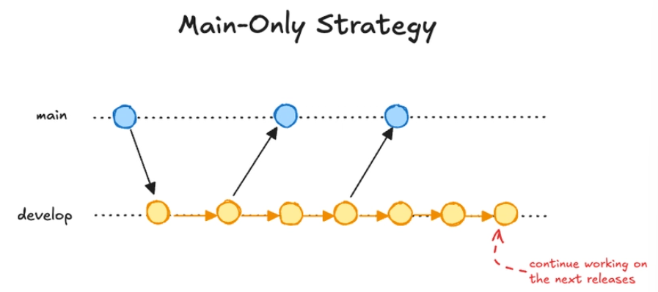

- All Development happens on single branch – main or master
Application which all code developers pushed code directly to “main”
- git checkout main
- git push origin main
- git add <fname>
- git commit -m “msg”
- git push origin main

Continuous Integration and Run Testing
Passes or fails

Failed: stop Deployment
Passed :Deployment

- Regression: New change that affect the working as like adding a new feature that affect the previous functionality of the application
git revert <new_commit> (returning to stable previous state)
git push origin main

- If that bad commit is deployed then we can “rollback” to previous deployment
deploy <prev_version> again

Pros | Cons
- No additional branch, No conflict | - Difficult to track process of each features
- Simple , easy to undertand | - Only unit test can be done
- Used when few dev are involved | - Hard to review code

- Feature Branching:
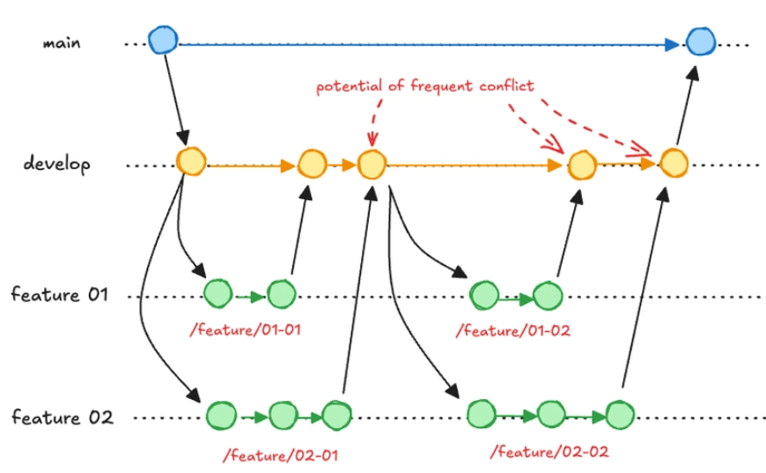
- Each feature= Each separate branch
- After pushing a branch, the developer opens a PR(Pull Request) to request review and approval from a teammate before the branch is merged into main
- After Testing, branches are merged into “main”
- CI fails: Blocks the merge to protect the shared codebase
Commands:
- git checkout main
- git checkout -b develop
- git pull
- git checkout -b feature
- git add <file_name>
- git commit -m “Message”
- git push origin feature
- git checkout develop
- git merge feature
- git push origin develop
- git checkout main
- git merge develop
- git push origin main

Pros: | Cons:
- Clear, modular code history | - Merge conflicts- 2 ppl editing same file
- Easy to Rollback if a branch affect or have a bug | - Longer the branch lives, more it creates risk and conflict
- Multiple developers can work on different features simultaneously | - Updating branches frequently- overhead
Notes:
- Pull Request:
- Asking permission to add changes to “main”, provide a controlled merging.
- Example: If there are 2 person (A,B) working on 2 diff features – login, payment , B completed and merged its changes to main and now A wants the latest commit from main so it uses “ git pull origin main”

- When to use Feature branch strategy?
- Working on multiple features
- Clear tracking of features

- Why to delete a branch after merging?
Branches are just a pointer now on merging main, feature they gets are common pointer , so on deleting it deletes the pointer not the code , thus making clean and organized workspace.

- GitFlow:
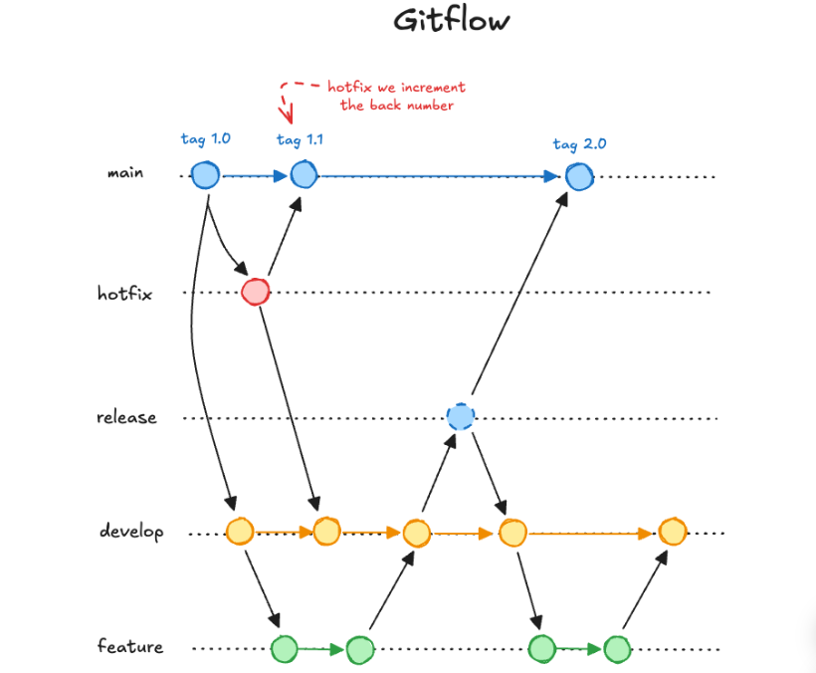
- Structured , multi-stage s/w development
- Persistent and ephemeral branches.

Persistent Branches
- Main – Stable Production code
- Develop-Work in progress, merge all completed features
- Release- Before Publish, create in develop , fix bugs
Ephemeral Branches:
- Feature- created and merged in develop, separate functionality
- Hotfix- Emergency usage, created and merged in main
Example:
I have a Cake shop where main- cake ready to sell, develop- making cake, feature-cream, toppin, release- taste testing, hotfix-emergency if too much sugar or other bug

Commands:
git checkout main
git checkout -b develop
git push origin develop
git checkout develop
git checkout -b fetaure1
git add,

Commands:
git add .
git commit -m “msg”
git push origin feature1
git checkout develop
git merge feature1
git branch -d feature1
git push origin --delete feature1
git checkout -b release1.0
git checkout main
git merge release1.0
git checkout -b hotfix
git checkout main
git merge hotfix

Pros: | Cons:
- Frequent release, short production cycle | - Not ideal for rapid and continuous deployment needs
- Well-suited for parallel development,Safe Hotfix, large teams | - Time consuming- overhead

- GitHub Flow:
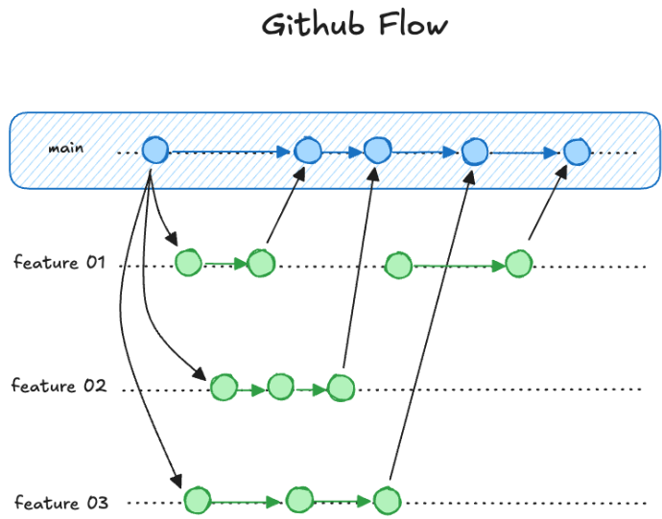
- Developers create feature branches, merge them into the main branch, and deploy immediately.
- Branch naming convention - /{author}/{short_description}
Commands
- git checkout main
- git pull
- git checkout -b rithika/add_btn
- git add .
- git commit -m “msg”
- git push origin rithika/add_btn
- Pull Request in GitHub UI -> Review and Merge
- git checkout main
- git pull
- git merge rithika/add_btn
- git push origin main
- git branch -d rithika/add_btn
- git push origin –delete rithika/add_btn

Pros: | Cons:
- It have only feature branch with PR thus easy to use | - Not ideal for long term development
- Continuous deployment with rapid feedback | - Potential instability with main branch should always be ready

- Trunk-Based Development:

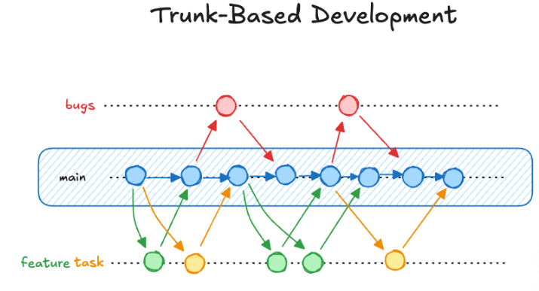

- Instead of long feature branches, they make small branches or commit straight to main.
- Changes are small, frequent, Branches are short lived for few hrs
- Beast for Agile Team, Strong CI/CD
- Trunk = main branch
- Ex: Imagine having 3 ppl to change bg clr, add btn, fix spelling mistake , then they create separate 3 small branch and merge them .
Commands:
- git checkout main
- git pull
- git checkout -b add_btn
- git add .
- git commit -m "Msg"
- git push origin add_btn
- git checkout main
- git pull
- git merge add_btn
- git push origin main
- git branch -d add_btn
- git push origin –delete add_btn

Pros |  | Cons
- Fewer Merge Conflicts , Development cycle are faster | - All commit go directly to “main”- Main branch can become unstable if proper testing isn’t enforced.
- Encourage collaboration | - Strict Testing process

- Release Branching:

Ex: I have 3 edition of textbook -of year 2023, 2024, 2025 , If there is mistake in edition 2023 , then only that is corrected not all future one
- main → stable code
- release branches → prepare and test version
- feature branches → build new features
- hotfix branch → urgent fixes for production
- Separate branches are maintained for each release version, often labeled with version numbers.
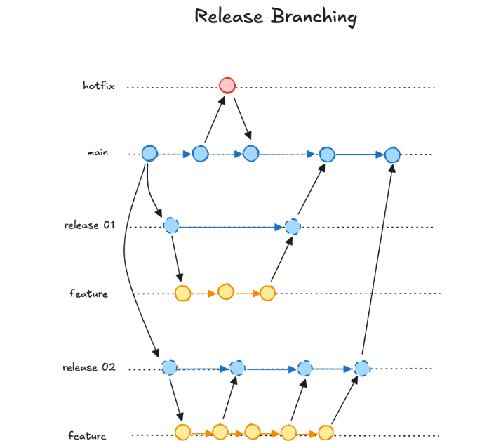

Pros: | Cons:
- Clear history of all releases. | - Too many branches can become unmanageable.
- Projects with long-term support (LTS) requirements | - Not ideal for fast-moving project

Commands:

- git checkout main
- git checkout -b feature1
- git add .
- git commit -m "Msg”
- git push -u origin feature1
- git checkout main
- git checkout -b release/v1.1
- git merge feature1
- git push origin release/v1.1
- git branch -d feature1
- git push origin --delete feature1

- git checkout main
- git merge release/v1.1
- git tag -a v1.1 -m "version 1.1"
- git push origin main --follow-tags
- git checkout main
- git checkout -b hotfix1
- git checkout main
- git merge hotfix1
- git tag -a v1.1.1 -m "Fix "
- git push origin main --follow-tags
- git branch -d hotfix1
- git push origin --delete hotfix1

Common Issues and Their Solutions: (Learning few Advanced Commands)
- Merge Conflict: change in 2 branch affects same file lines
- Open & remove conflict markers( >>>>>>, =======,..)
- Add the resolved file
- Regularly pull changes from base branch
- Forgotten Branch Merge, Branch Bloat(Too many branch causes clustering repo):
- Branch being forgotten
- git branch -d <bname>( Dlt branch only if merged already)
- git branch -D <bname>(Force dlt even if not merged)
- Large Divergences Betwwen Branches:
- When two branches are separate for a long time, they accumulate many commits independently.
- So when you finally try to merge them, many merge conflicts occur because the same files or lines have changed in different ways
- Use : git rebase
- Unclear Branch Purpose:
- Use descriptive name, enforce a branch naming convention.
- Like : rithika/add_btn( work in a team)
- Accidental Pushes to Wrong Branch:
- Use : git reset –hard origin/main( All local changes and commits that are not on the remote will be deleted permanently.)
- git push –force( Pushing changes to remote even if it overwrite)
- Deleted or Lost Branch:
- Branch deleted accidently by use of “ git reset –hard <prev_commit> “
- Use : git reflog (history of everything your HEAD has pointed to)
- git checkout -b restore <commit_hash>( connect the restored branch with old)

